**A Brief Overview:**

**(i) Software and Library Requirements :**

**Visual Studio 2012:**The game uses Visual C++ 11 (2012) - 32 bitsstatic version is included in the zip file(source code zip folder). The solution has been pre-configured for usage with SFML library. To open the solution, you will need to have some version of Visual Studio 2012 installed. Here is the download link for the express (free) version <http://www.microsoft.com/en-in/download/details.aspx?id=34673>.  
But I would not suggest downloading 608 MBs . I have downloaded the .iso file you can take that and install Visual Studio Express 2012 . **SFML:**The game uses SFML 2.1 library. For those who are not aware of what SFML 2.1 library , it is Simple and Fast Multimedia Library (SFML) a portable API for multimedia programming. It is written in C++ with bindings available for C, D,Python, Ruby, OCaml, . Net and Go. It can be thought of as an object oriented alternative to SDL.  
SFML provides hardware accelerated 2D graphics using OpenGL, supports OpenGL windowing and provides different modules that ease multimedia and game programming.  
No prior knowledge of this library is required in order to code. Only some basic stuff is required which I will share with you all .

**(ii) Setting up the dumb bot :**

1. 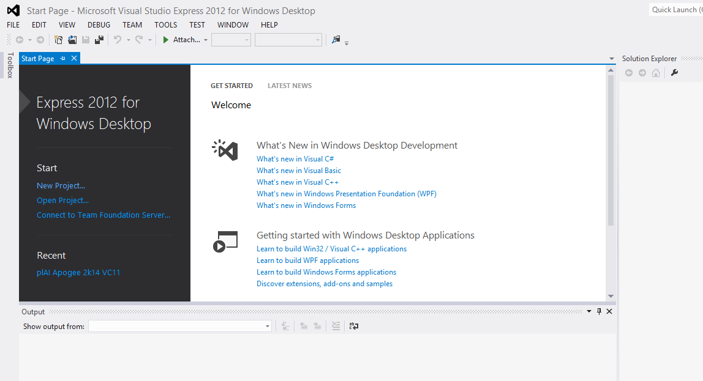**Install Visual Studio Express . You can either use the following link:** <http://www.microsoft.com/en-in/download/details.aspx?id=34673> (after successful installation it will look like)  
   **Or you can take the .iso file from me because downloading a 608 MB file will take long time .**

**For installing through the .iso file you just have to extract the file first and then click on '**wd*_expressfull.exe'* **.**

**Now Do The following:**

1. **Extract the source code file i.e. Game Src Code 23 Feb 2014 2230h.zip .**
2. **After extracting everything change your directory to** *Game Src Code 21 Feb 2014 2252h/plAI Apogee 2k14 VC11.*
3. **Open the file** *plAI Apogee 2k14 VC11.sln* **(note that file will open successfully only after installing Visual Studio 2012 )**
4. 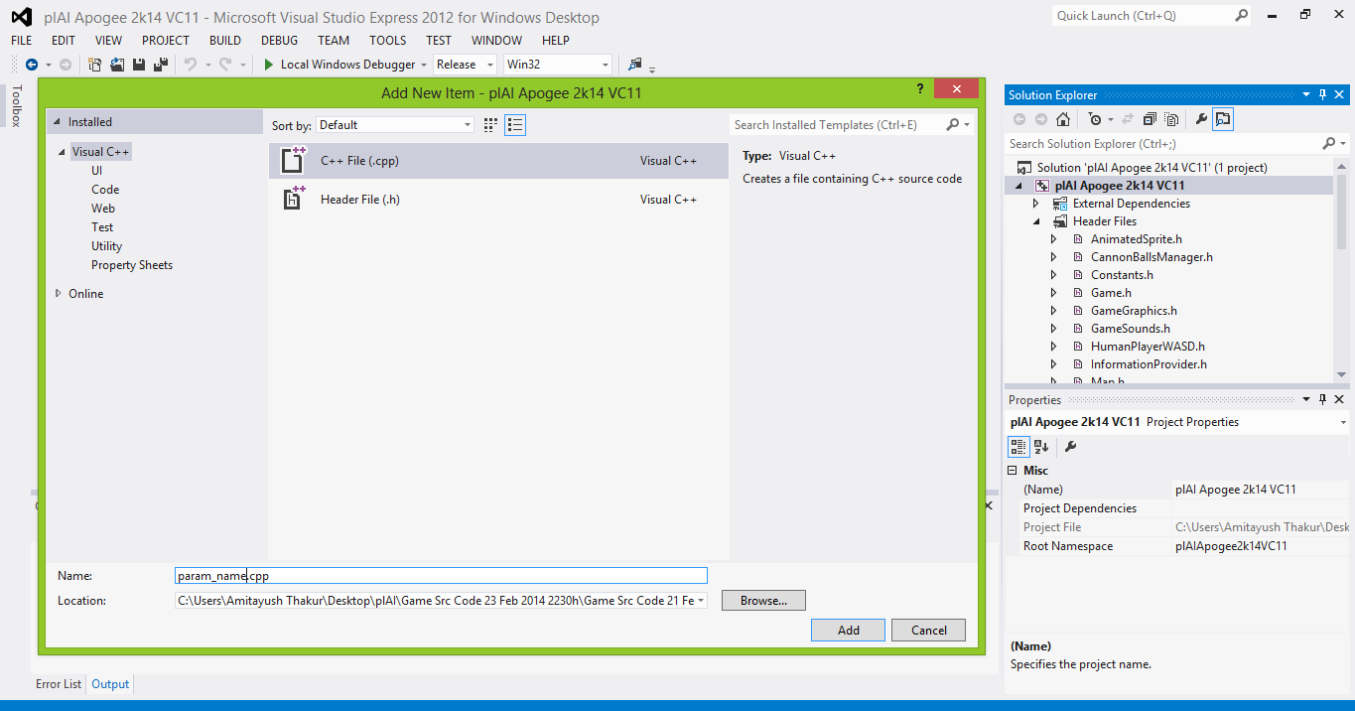**Create a** *new header file (*.h)* **and a** *new source file (*.cpp)* **and add them to the solution. You can use “***Ctrl + Shift + A***” in Visual Studio to add new files. Add two files with the file name** *param_name.h* **and**   
   *param_name.cpp .* **(param_name is our team name).  
   The following screen will appear once you press** ' *Ctrl + Shift + A* ' .
5. **Add the following code to** *param_name.h* :

#pragma once

#include"Player.h"

class param_name : public Player

{

private:

//Declare your data structures here

public:

void initialise(InformationProvider* info);

RaftControls controlRaft(InformationProvider* info);

void getTeamName(char teamName[]);

};

**7. Add the following code to** *param_name.cpp* :

#include"param_name.h"

#include"VectorOps.h"

using namespace sf;

void param_name::initialise(InformationProvider* info)

{

//Initialise your data structures here

}

RaftControls param_name::controlRaft(InformationProvider* info)

{

//Your AI code goes here

return RaftControls(Vector2f(0, 0), false, Vector2f(0, 0));

}

void param_name::getTeamName(char teamName[])

{

strcpy_s(teamName, 256, "Param Name");

}

8.**Now comes testing your dumb bot. Open the file Constant.h**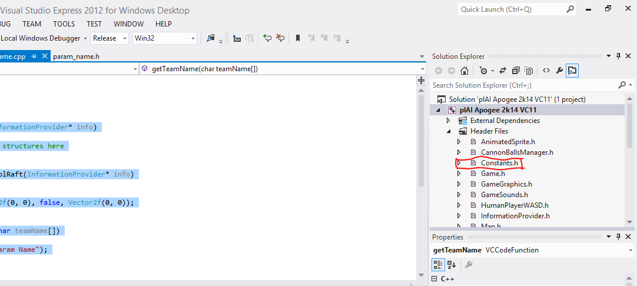

**9. Open the file “***Constants.h***”, and navigate to this part of the code:**  
 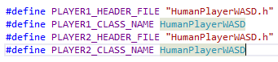

**Change it to :**  
 #define PLAYER1_HEADER_FILE "param_name.h"

#define PLAYER1_CLASS_NAME param_name

#define PLAYER2_HEADER_FILE "param_name.h"

#define PLAYER2_CLASS_NAME param_name

**10. Compile the game and run it (*Press******F5*** *in Visual Studio***).**

**11. If everything is fine then you will see the following screen:**

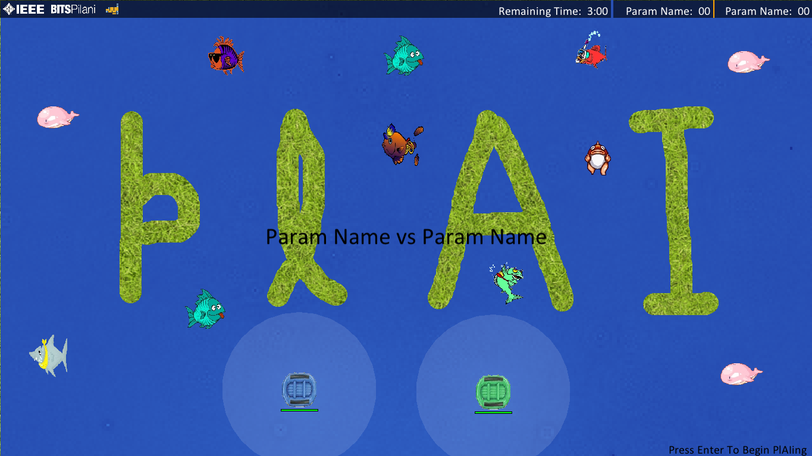

**After pressing Enter the screen will change to :  
 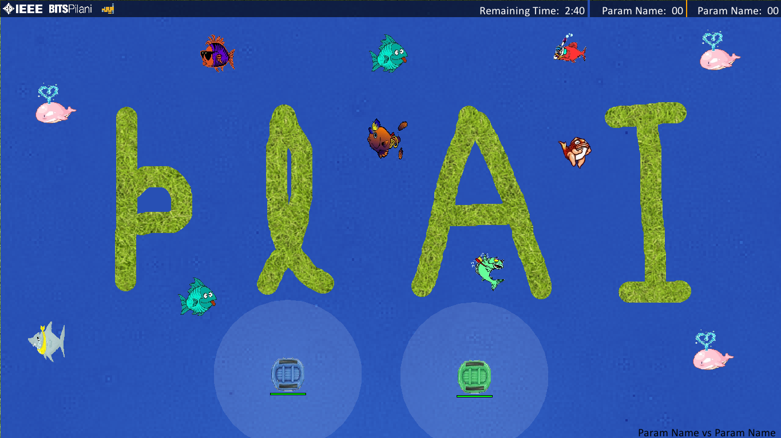**

**Now the game will start and time will be counted. If everything goes right, you should be able to see two rafts, one of which you should be able to control using W,A,S,D; and one which does nothing. The one which does nothing is the one being controlled by your dumb bot.**

**To exit the game press *'Escape Key'* , the following screen will appear :  
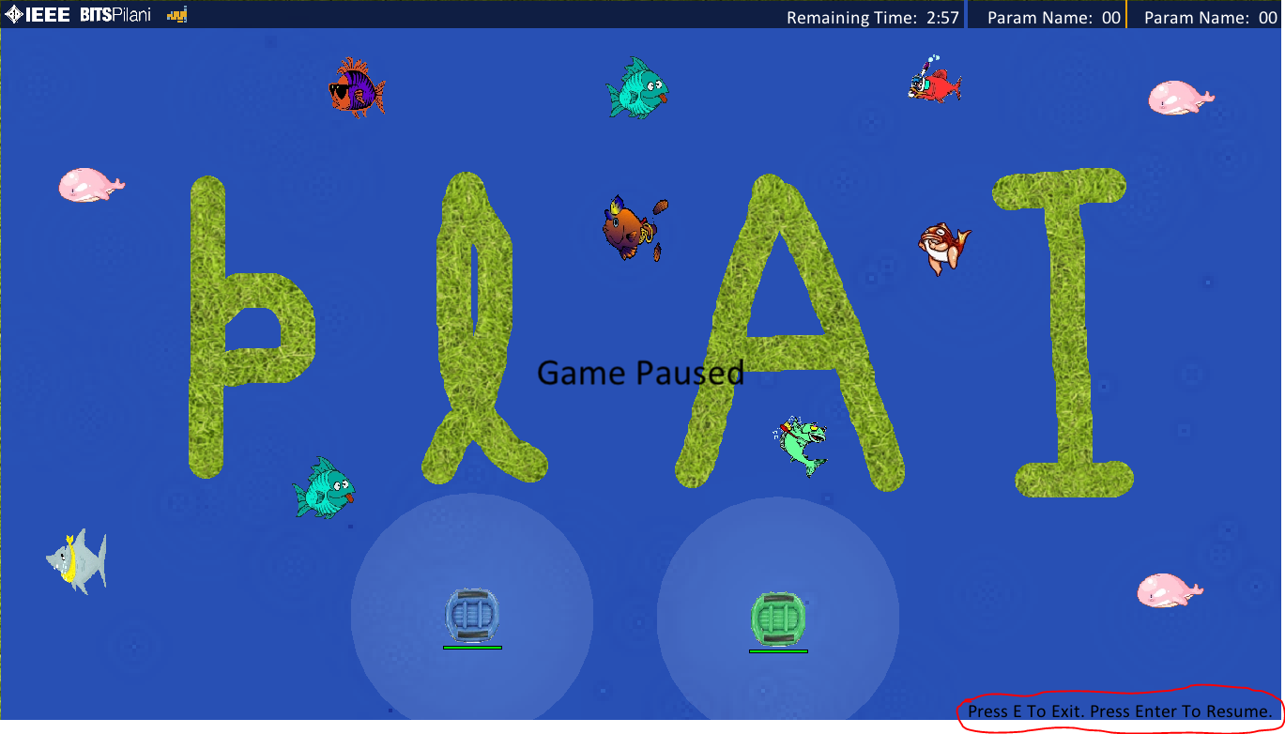**

**Press '*e*' to exit or '*Enter*' to resume.**